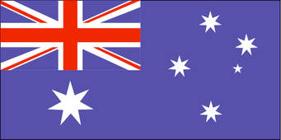

Looking for any information on the Dundons of Kilrush County Clare.

Specifically Michael Dundon born 1828 and marrying Elizabeth Clancy in Victoria after emigrating to Australia in 1857.

Michael’s father Patrick married Deborah Lynch of Kilrush in 1823. They lived in “The Glen” in Kilrush, County Clare. Patrick died around 1857 prompting Deborah and her sons to emigrate to Melbourne minus their daughter Bridgit who stayed in Ireland. I believe Patrick was a plasterer.

Michael born 1828 had brothers John born 1827 who settled in Sydney and ran a hotel in Surry Hills married Johannah Dillon, Philip born 1829 stayed in Melbourne and married Bridgit Kelly and their sister Bridgit born 1836 stayed in Kilrush and married John McMahon. Michael and Elizabeth eventually moved to Dunedin in New Zealand where they died.

Deborah Dundon nee Lynch had parents Michael Lynch and Bridgit Moran. I believe the Lynch’s were slaters.

Looking for the Dundon line and more information on Patrick and his lineage and possibly a connection to the Dundons of Crecora and Jockey Hall.

Any information please contact Stephen zenliving3@bigpond.com

